The QR code of the home page is invalid

**Used Device/Browser:**

- Firefox (Version 69.0.1 (64-bit)) on Windows 7

**Steps to reproduce:**

- Open the <http://www.007museum.com/>

- QR Code is invalid

Screenshot:

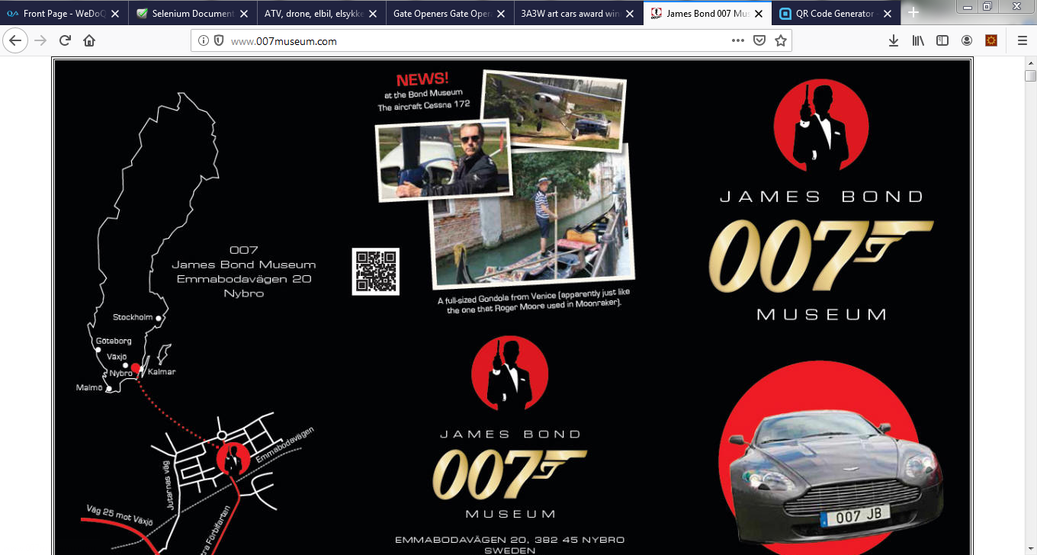

The link is not displayed properly

**Used Device/Browser:**

- Firefox (Version 69.0.1 (64-bit)) on Windows 7

**Steps to reproduce:**

- Open the <http://www.007museum.com/>

- Open find on this page ctrl + f

- Paste this: Eva Green

- Check the link

- It is not displayed correctly

Screenshot: 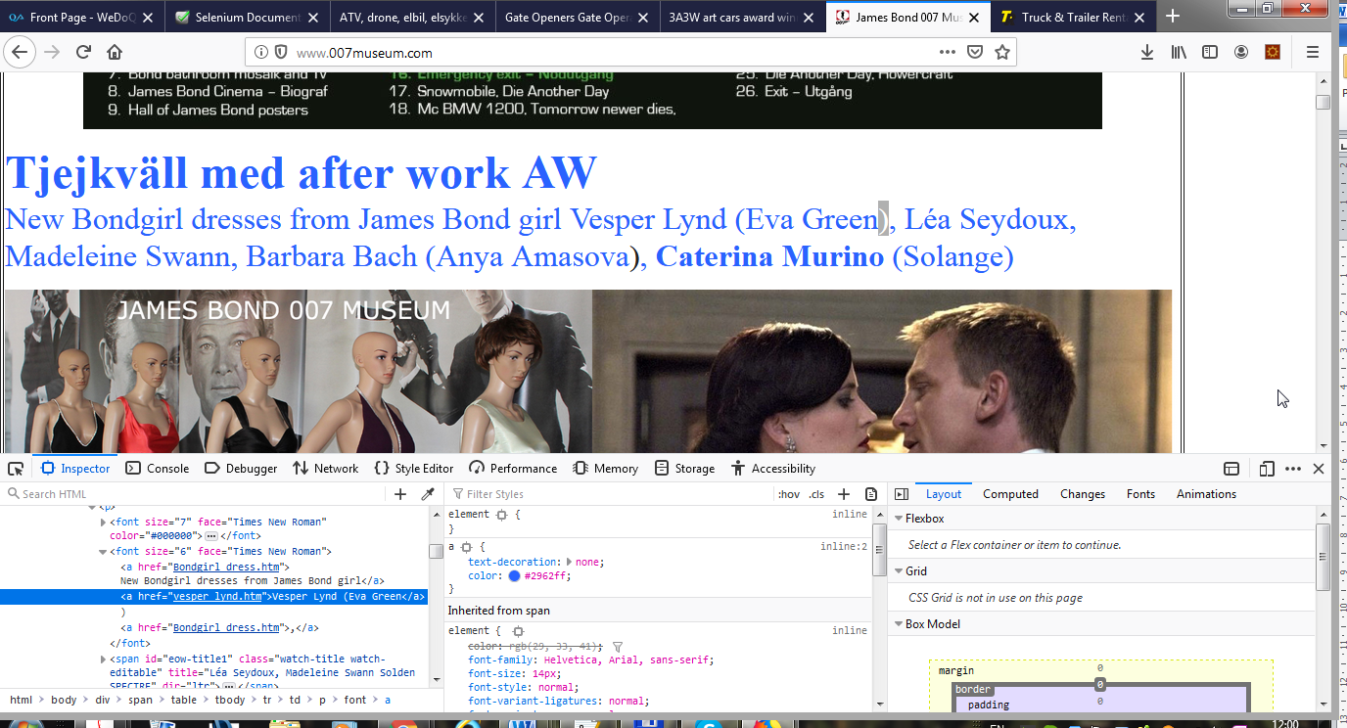

The link is not displayed properly

**Used Device/Browser:**

- Firefox (Version 69.0.1 (64-bit)) on Windows 7

**Steps to reproduce:**

- Open the <http://www.007museum.com/>

- Open find on this page ctrl + f

- paste this: helicopter autogiro

- Check the link

- It is not displayed correctly double quotes

Screenshot: 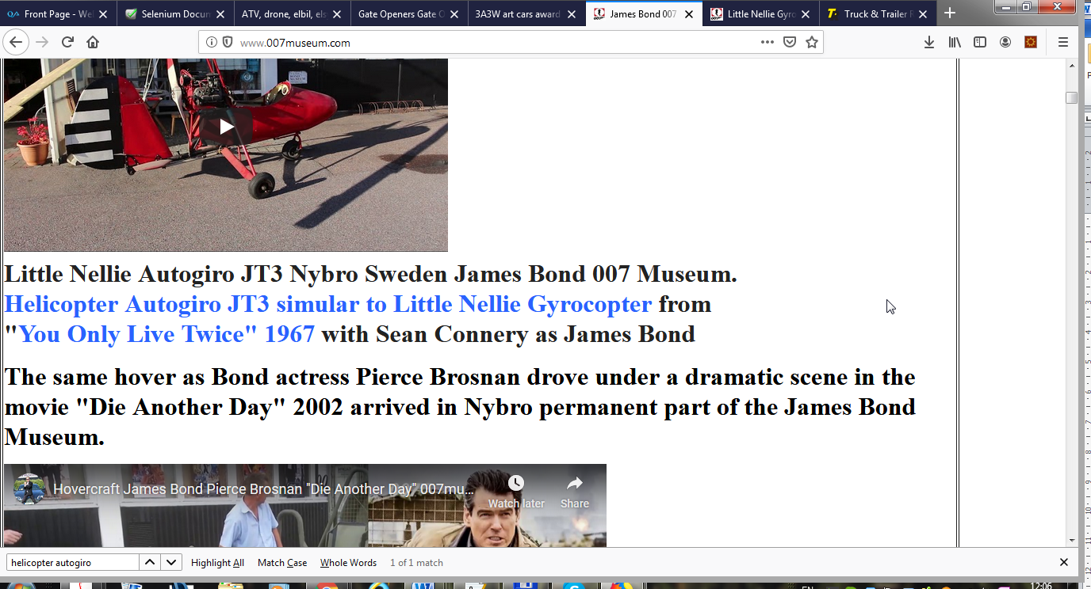

The link is not displayed properly

**Used Device/Browser:**

- Firefox (Version 69.0.1 (64-bit)) on Windows 7

**Steps to reproduce:**

- Open the <http://www.007museum.com/>

- Open find on this page ctrl + f

- paste this: aston martin with

- Check the link

- It is not displayed correctly double quotes

Screenshot: 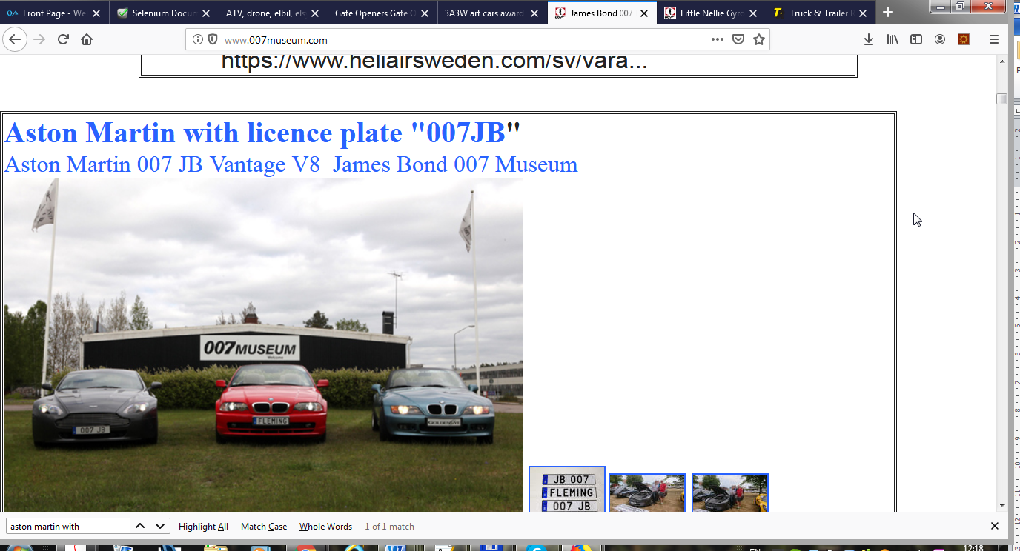

The link is not displayed properly

**Used Device/Browser:**

- Firefox (Version 69.0.1 (64-bit)) on Windows 7

**Steps to reproduce:**

- Open the <http://www.007museum.com/>

- Open find on this page ctrl + f

- paste this: Svensk James Bond Bond-museet har även en

- Check the link

- It is not displayed correctly double quotes

Screenshot: 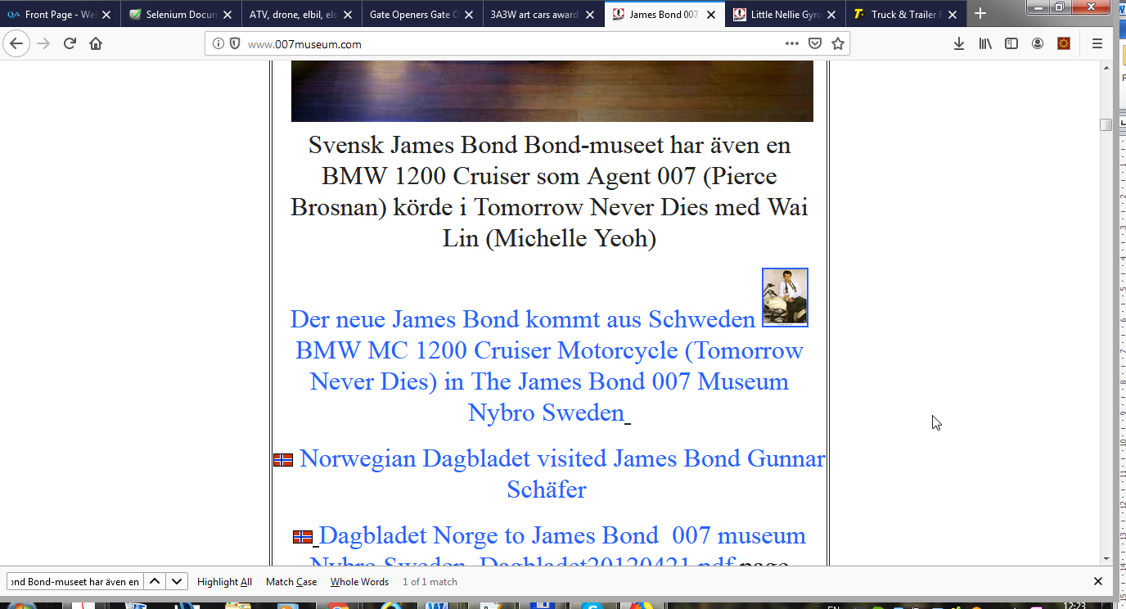

The social icon Tweet displayed two times and point to same thing

**Used Device/Browser:**

- Firefox (Version 69.0.1 (64-bit)) on Windows 7

**Steps to reproduce:**

- Open the <http://www.007museum.com/>

- Open find on this page ctrl + f

- paste this: cessna plane 172

- Check the icon

- It is displayed two times

Screenshot:

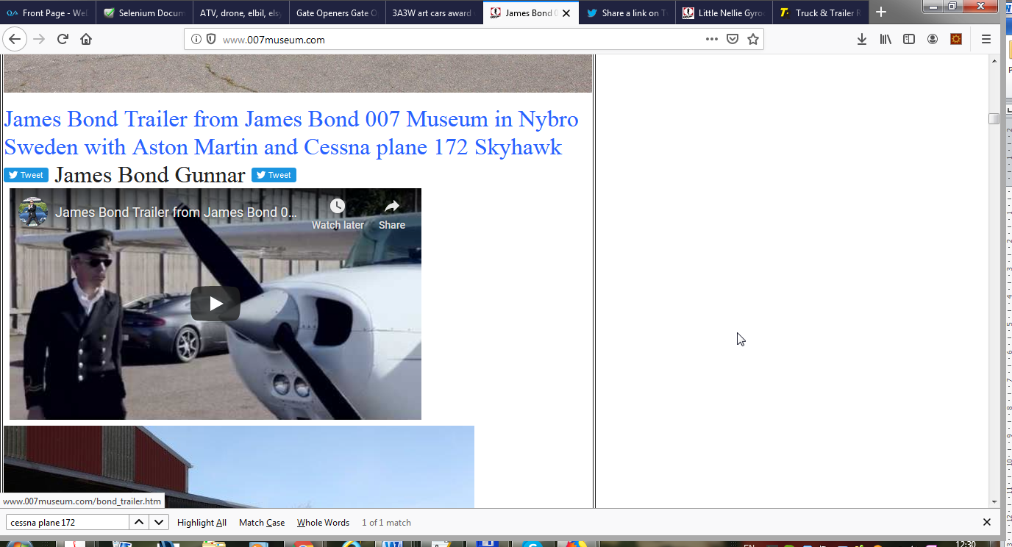

The link is not displayed properly

**Used Device/Browser:**

- Firefox (Version 69.0.1 (64-bit)) on Windows 7

**Steps to reproduce:**

- Open the <http://www.007museum.com/>

- Open find on this page ctrl + f

- paste this: rent hire aston

- Check the link

- It is not displayed correctly

Screenshot:

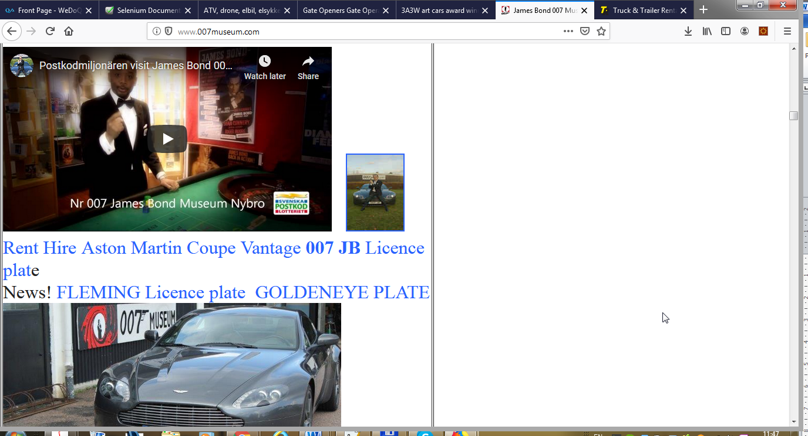

The link is not displayed properly

**Used Device/Browser:**

- Firefox (Version 69.0.1 (64-bit)) on Windows 7

**Steps to reproduce:**

- Open the <http://www.007museum.com/>

- Open find on this page ctrl + f

- paste this: 1000

- Check the link

- It is not displayed correctly

Screenshot:

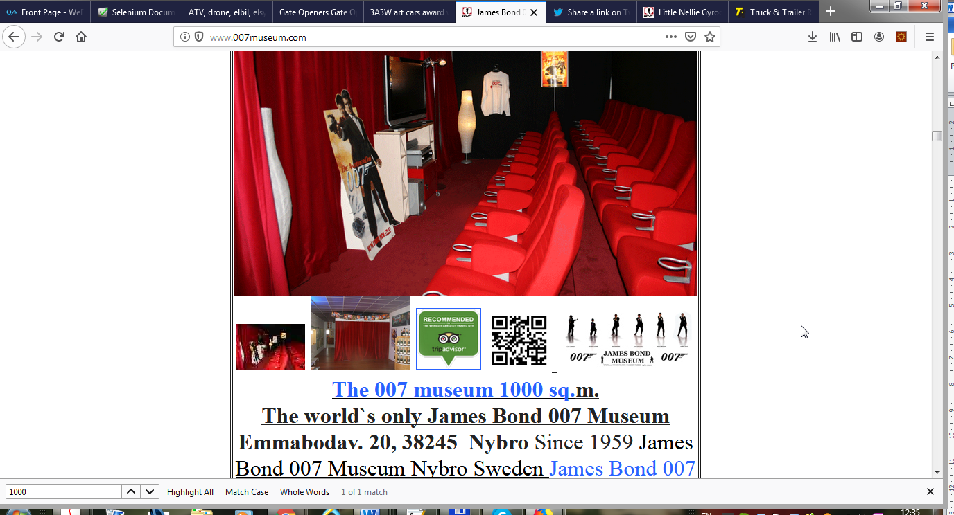

The date is not displayed properly

**Used Device/Browser:**

- Firefox (Version 69.0.1 (64-bit)) on Windows 7

**Steps to reproduce:**

- Open the <http://www.007museum.com/>

- Open find on this page ctrl + f

- paste this: 20151217

- Check the date

- It is not displayed correctly

Screenshot:

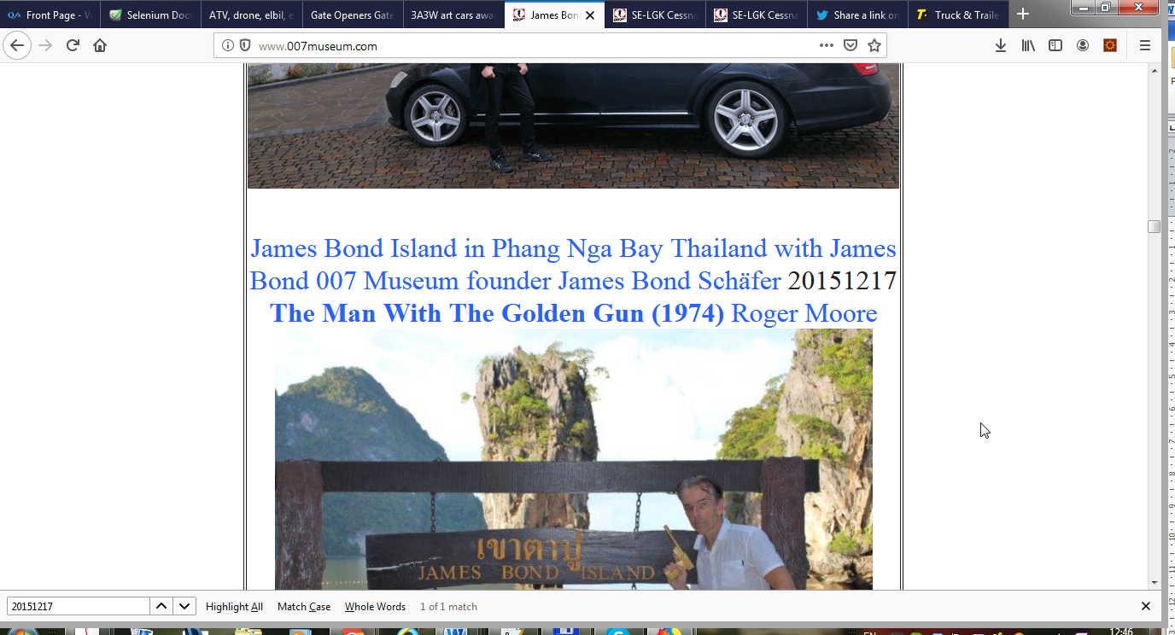

The date is not displayed properly

**Used Device/Browser:**

- Firefox (Version 69.0.1 (64-bit)) on Windows 7

**Steps to reproduce:**

- Open the <http://www.007museum.com/>

- Open find on this page ctrl + f

- paste this: 9/2-2018

- Check the date

- It is not displayed correctly

Screenshot:

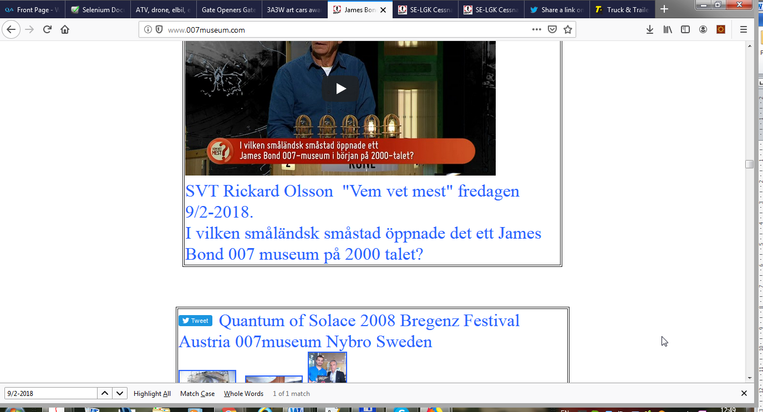

The date is not displayed properly

**Used Device/Browser:**

- Firefox (Version 69.0.1 (64-bit)) on Windows 7

**Steps to reproduce:**

- Open the <http://www.007museum.com/>

- Open find on this page ctrl + f

- paste this: 2 juli 2016

- Check the date

- It is not displayed correctly

Screenshot:

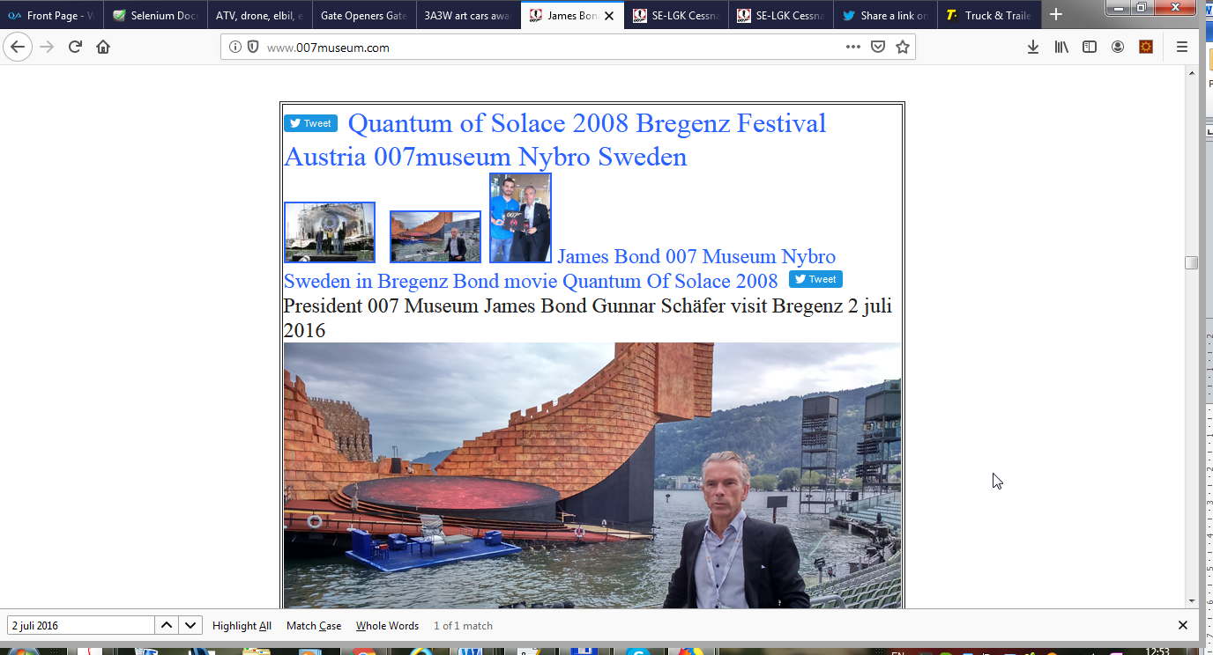

The date is not displayed properly

**Used Device/Browser:**

- Firefox (Version 69.0.1 (64-bit)) on Windows 7

**Steps to reproduce:**

- Open the <http://www.007museum.com/>

- Open find on this page ctrl + f

- paste this: April 19

- Check the date

- It is not displayed correctly

Screenshot:

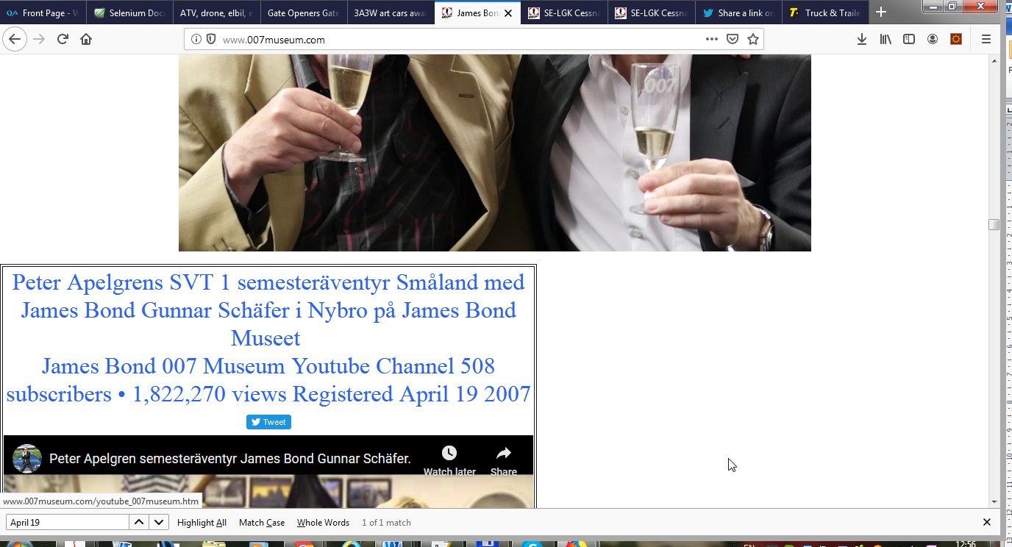

The date is not displayed properly

**Used Device/Browser:**

- Firefox (Version 69.0.1 (64-bit)) on Windows 7

**Steps to reproduce:**

- Open the <http://www.007museum.com/>

- Open find on this page ctrl + f

- paste this: 21 juli

- Check the date

- It is not displayed correctly

Screenshot:

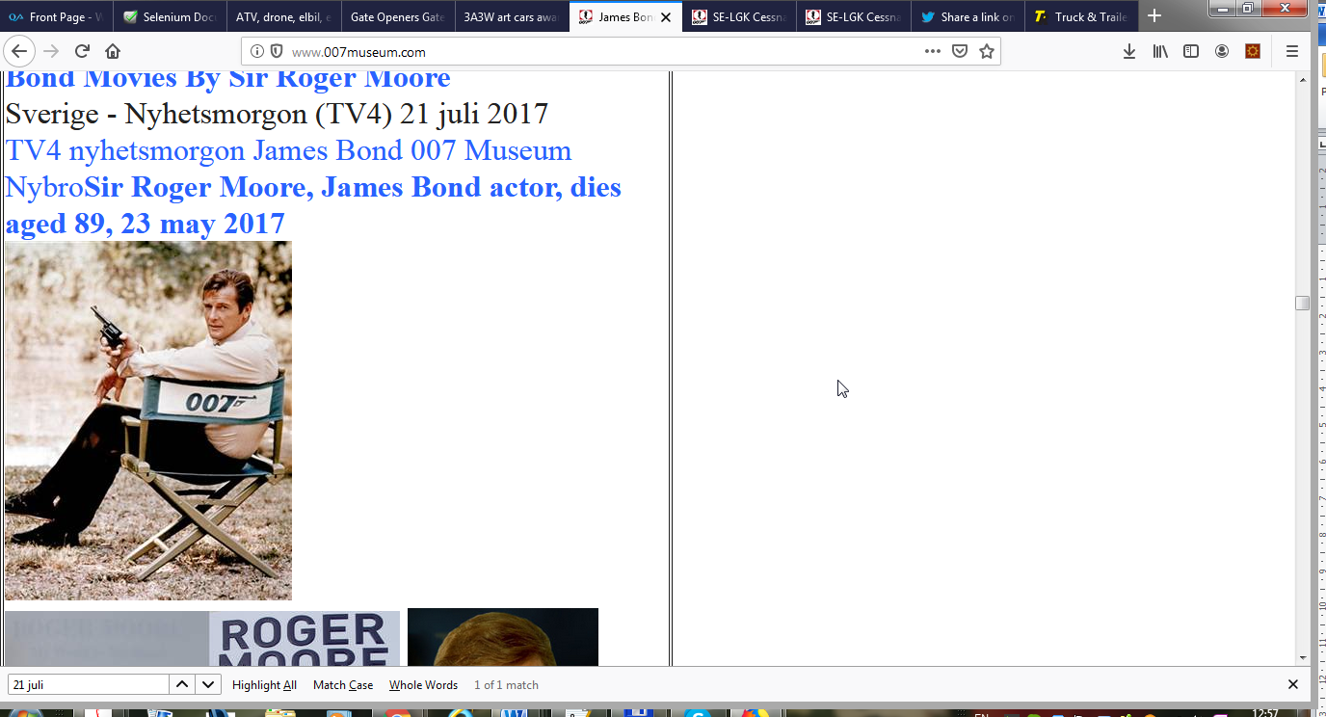

The date is not displayed properly

**Used Device/Browser:**

- Firefox (Version 69.0.1 (64-bit)) on Windows 7

**Steps to reproduce:**

- Open the <http://www.007museum.com/>

- Open find on this page ctrl + f

- paste this: 23 maj

- Check the date

- It is not displayed correctly

Screenshot:

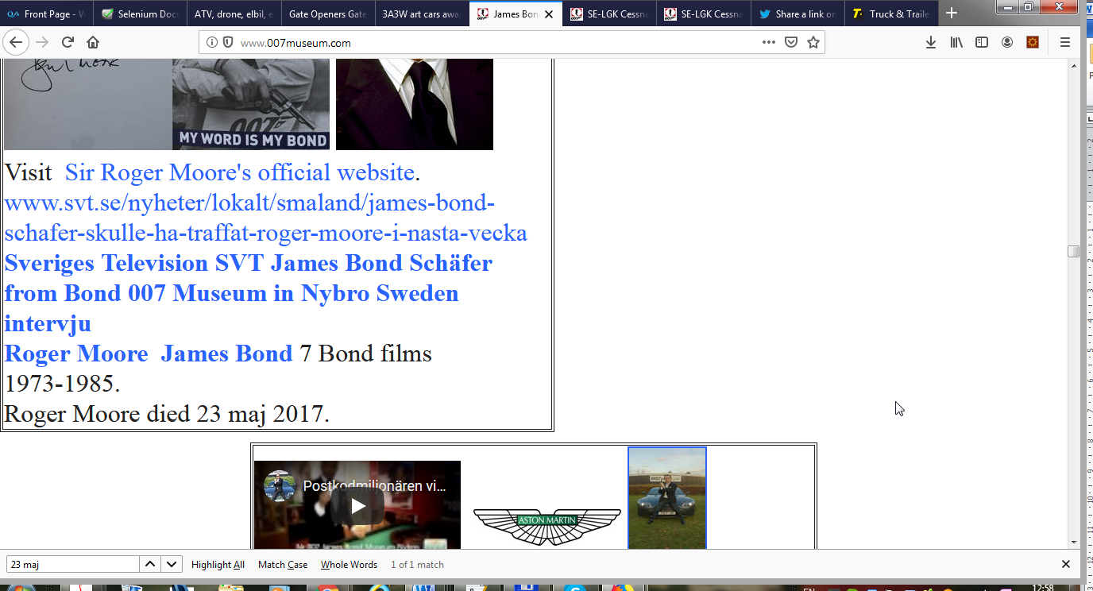

The link is not displayed properly

**Used Device/Browser:**

- Firefox (Version 69.0.1 (64-bit)) on Windows 7

**Steps to reproduce:**

- Open the <http://www.007museum.com/>

- Open find on this page ctrl + f

- paste this: rent hire aston

- Check the link

- It is not displayed correctly

Screenshot:



The link is not displayed properly

**Used Device/Browser:**

- Firefox (Version 69.0.1 (64-bit)) on Windows 7

**Steps to reproduce:**

- Open the <http://www.007museum.com/>

- Open find on this page ctrl + f

- paste this: School education

- Check the link

- It is not displayed correctly

* Text
* Social icons

Screenshot:

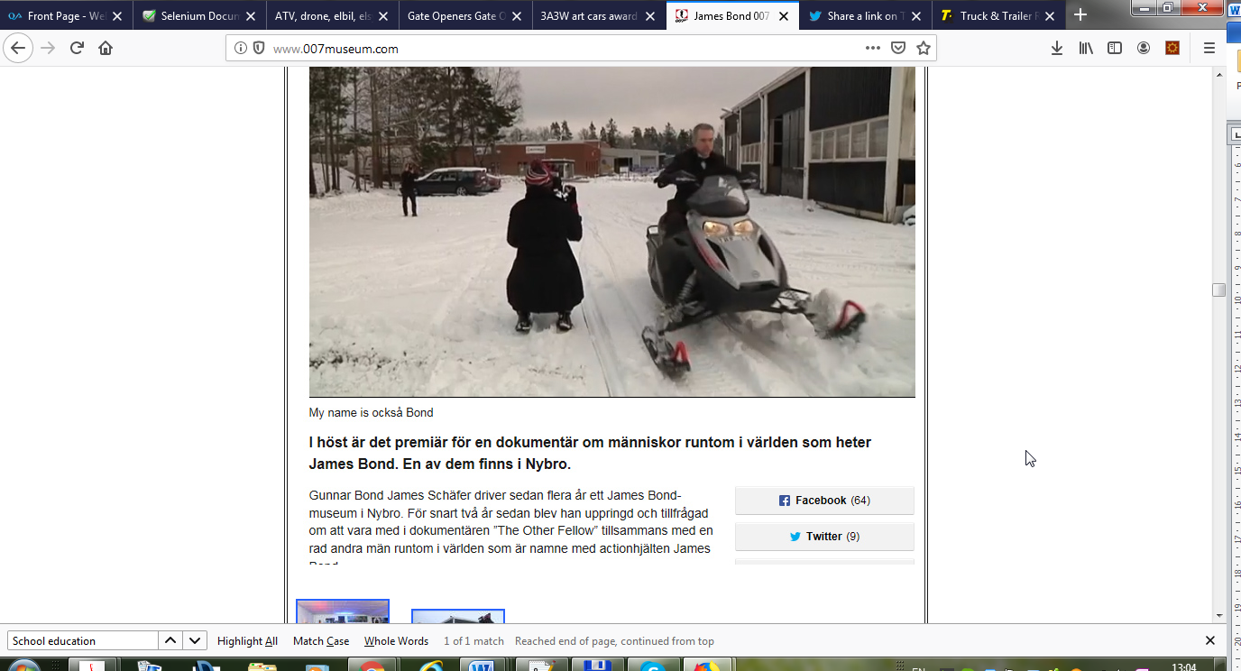

The date is not displayed properly

**Used Device/Browser:**

- Firefox (Version 69.0.1 (64-bit)) on Windows 7

**Steps to reproduce:**

- Open the <http://www.007museum.com/>

- Open find on this page ctrl + f

- paste this: 2 maj

- Check the date

- It is not displayed correctly

Screenshot:

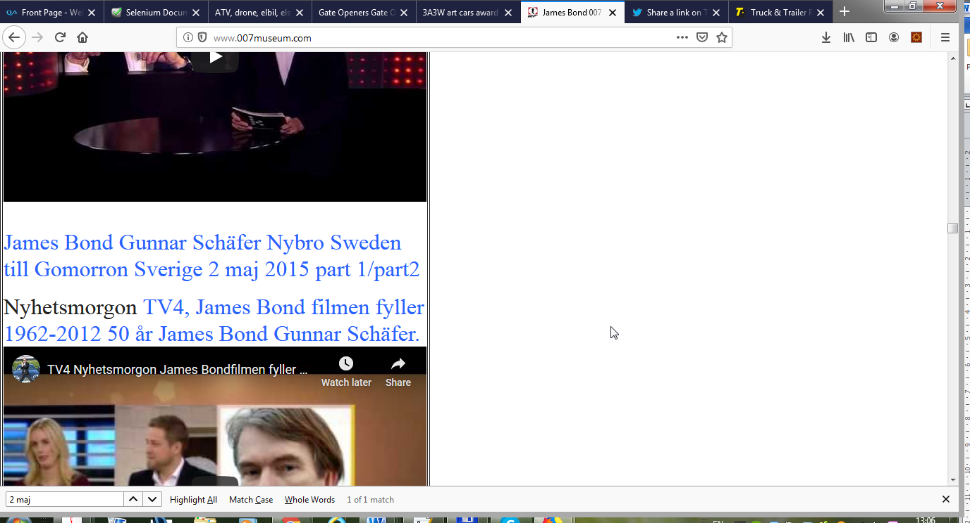

The date is not displayed properly

**Used Device/Browser:**

- Firefox (Version 69.0.1 (64-bit)) on Windows 7

**Steps to reproduce:**

- Open the <http://www.007museum.com/>

- Open find on this page ctrl + f

- paste this: 7/31/1997

- Check the date

- It is not displayed correctly

Screenshot:

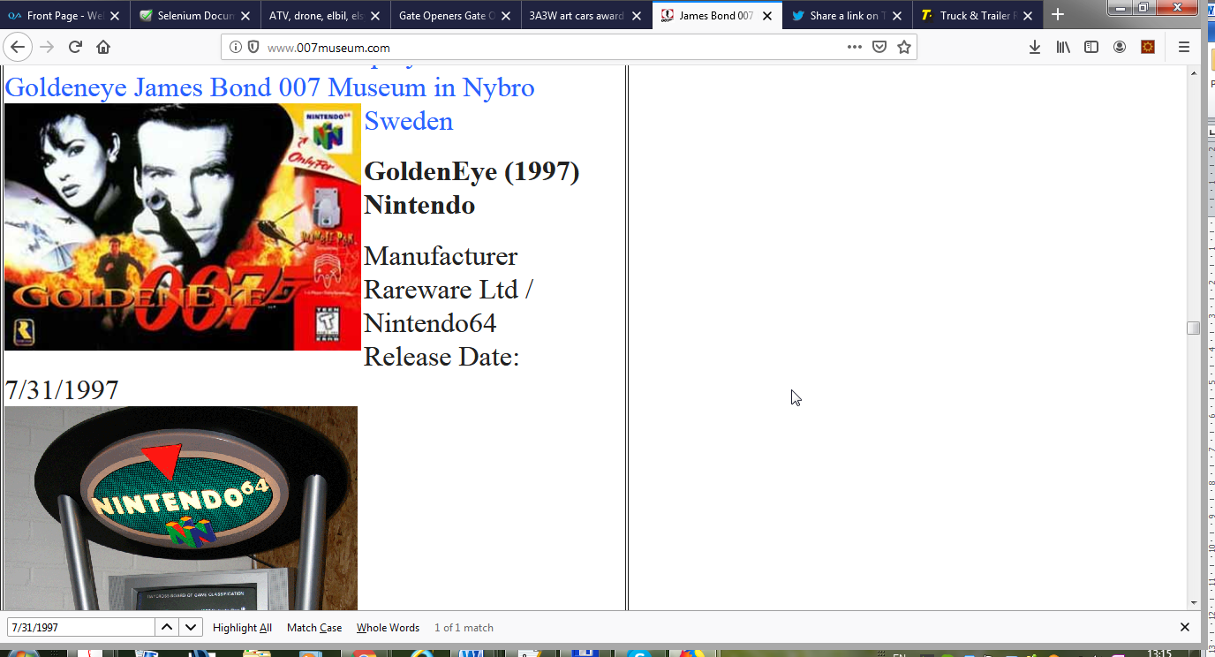

The link is not displayed properly

**Used Device/Browser:**

- Firefox (Version 69.0.1 (64-bit)) on Windows 7

**Steps to reproduce:**

- Open the <http://www.007museum.com/>

- Open find on this page ctrl + f

- paste this: 1985 Paris

- Check the link

- It is not displayed correctly

- It is not displayed correctly double quotes

Screenshot:

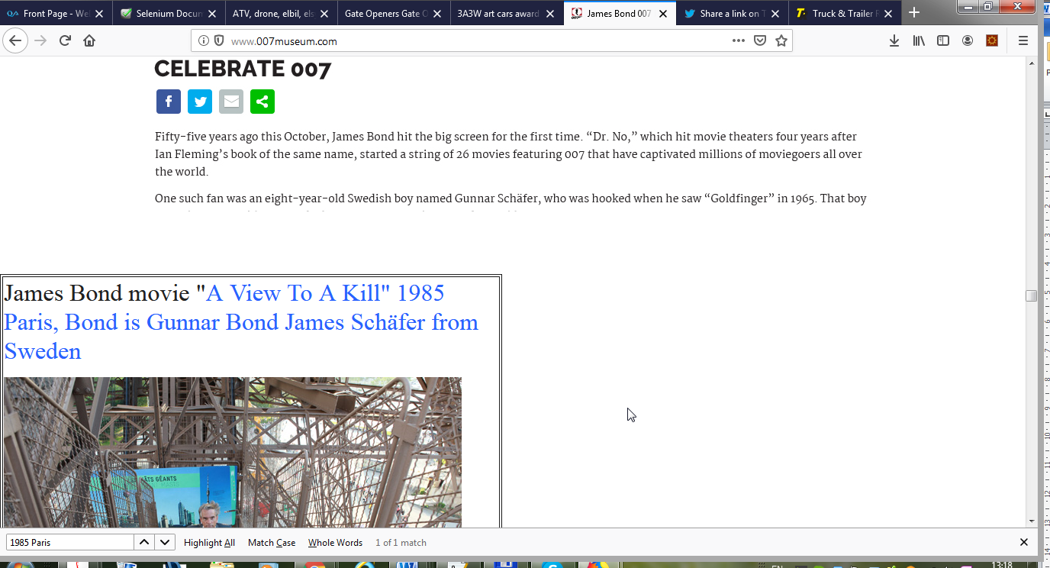

The date and text is not displayed properly

**Used Device/Browser:**

- Firefox (Version 69.0.1 (64-bit)) on Windows 7

**Steps to reproduce:**

- Open the <http://www.007museum.com/>

- Open find on this page ctrl + f

- paste this: januari 6 1998

- Check the date

- It is not displayed correctly

- Check the text after picture

- Check the link missing dot

Screenshot:

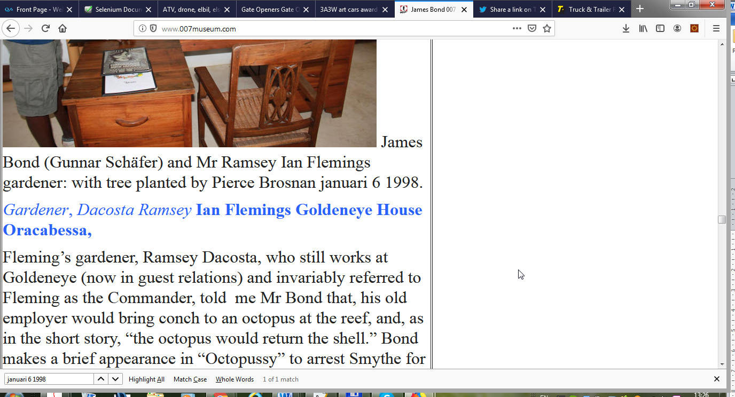

The date and text is not displayed properly

**Used Device/Browser:**

- Firefox (Version 69.0.1 (64-bit)) on Windows 7

**Steps to reproduce:**

- Open the <http://www.007museum.com/>

- Open find on this page ctrl + f

- paste this: april 2013

- Check the date

- It is not displayed correctly

- Check the text date

Screenshot:

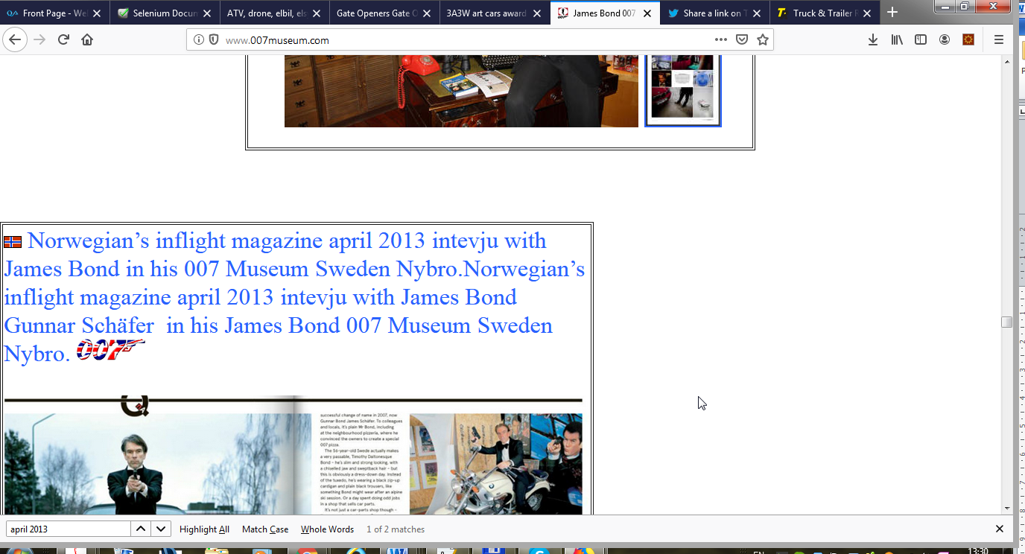

The link is not displayed properly

**Used Device/Browser:**

- Firefox (Version 69.0.1 (64-bit)) on Windows 7

**Steps to reproduce:**

- Open the <http://www.007museum.com/>

- Open find on this page ctrl + f

- paste this: skyfall.

- Check the link

- It is not displayed correctly

- It is not displayed correctly extra char

Screenshot:

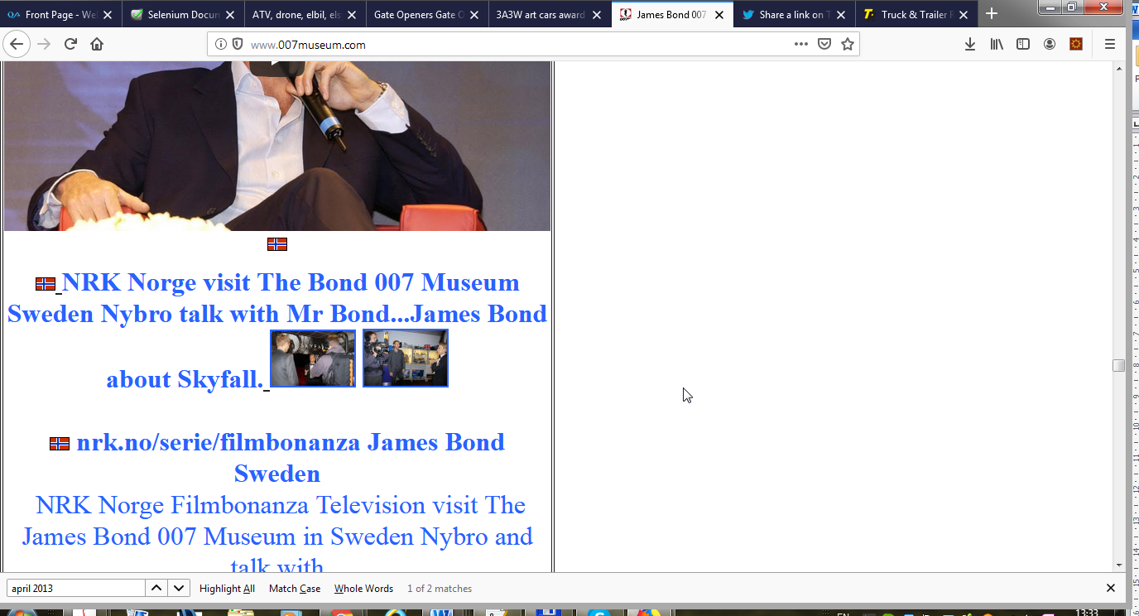

The date is not displayed properly

**Used Device/Browser:**

- Firefox (Version 69.0.1 (64-bit)) on Windows 7

**Steps to reproduce:**

- Open the <http://www.007museum.com/>

- Open find on this page ctrl + f

- paste this: 1911-03-28

- Check the date

- It is not displayed correctly

Screenshot:

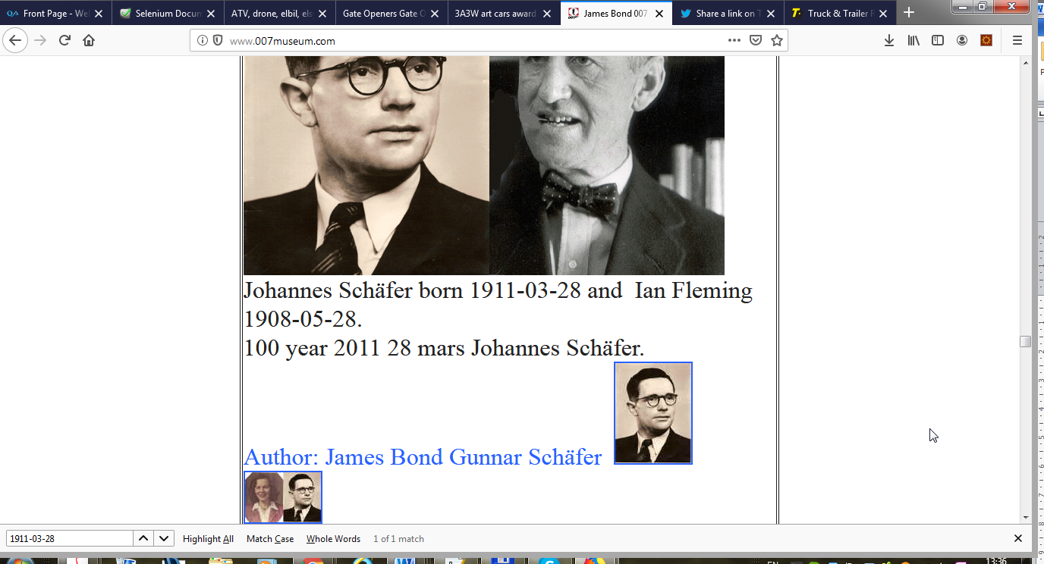

The link is not displayed properly

**Used Device/Browser:**

- Firefox (Version 69.0.1 (64-bit)) on Windows 7

**Steps to reproduce:**

- Open the <http://www.007museum.com/>

- Open find on this page ctrl + f

- paste this: per hallberg 3

- Check the link

- It is not displayed correctly

Screenshot:

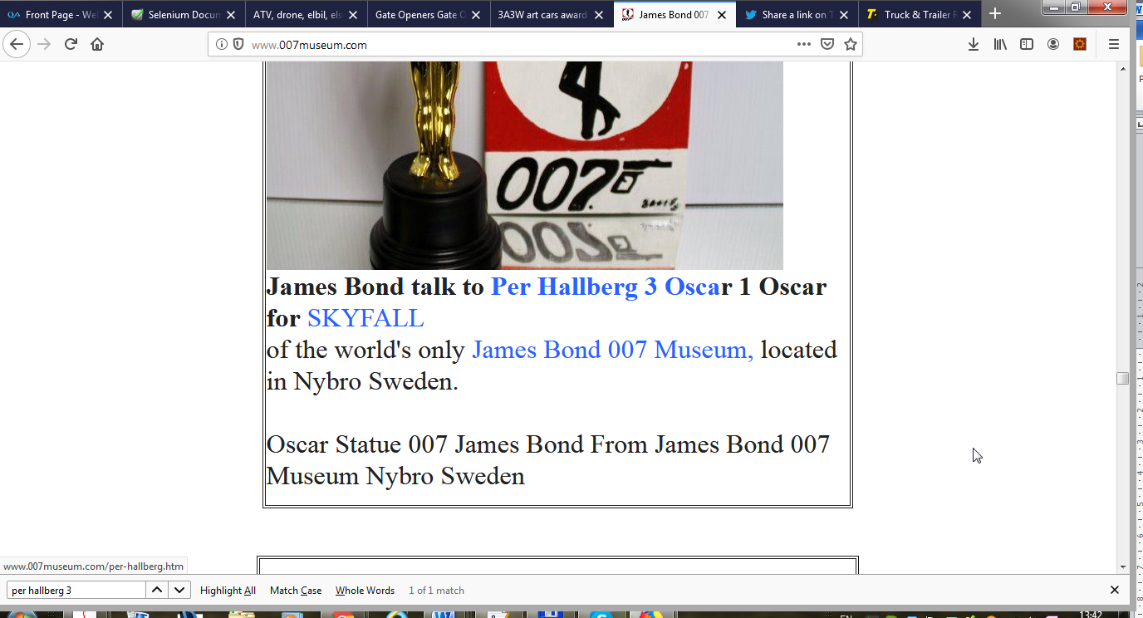

The date is not displayed properly

**Used Device/Browser:**

- Firefox (Version 69.0.1 (64-bit)) on Windows 7

**Steps to reproduce:**

- Open the <http://www.007museum.com/>

- Open find on this page ctrl + f

- paste this: Business Lunch

- Check the date

- It is not displayed correctly

Screenshot:

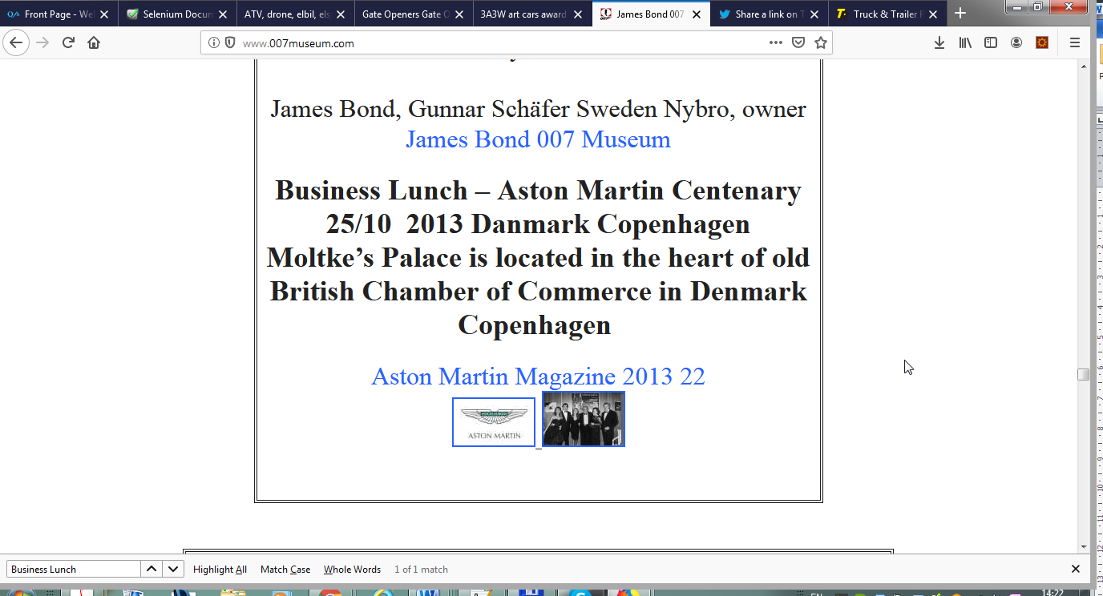

The date is not displayed properly

**Used Device/Browser:**

- Firefox (Version 69.0.1 (64-bit)) on Windows 7

**Steps to reproduce:**

- Open the <http://www.007museum.com/>

- Open find on this page ctrl + f

- paste this: 10/8-2016

- Check the date

- It is not displayed correctly

Screenshot:

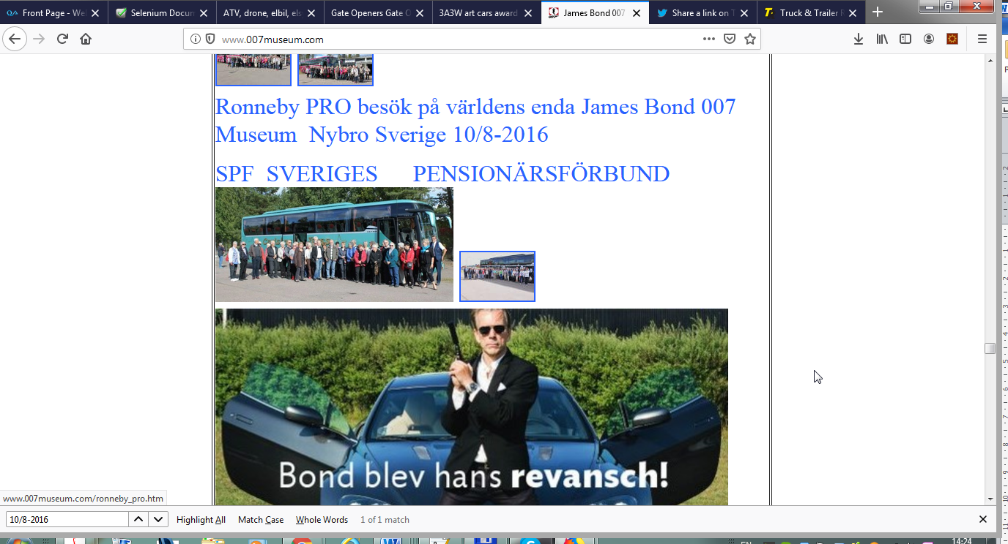

The date is not displayed properly

**Used Device/Browser:**

- Firefox (Version 69.0.1 (64-bit)) on Windows 7

**Steps to reproduce:**

- Open the <http://www.007museum.com/>

- Open find on this page ctrl + f

- paste this: 22/4-2016

- Check the date

- It is not displayed correctly

Screenshot:

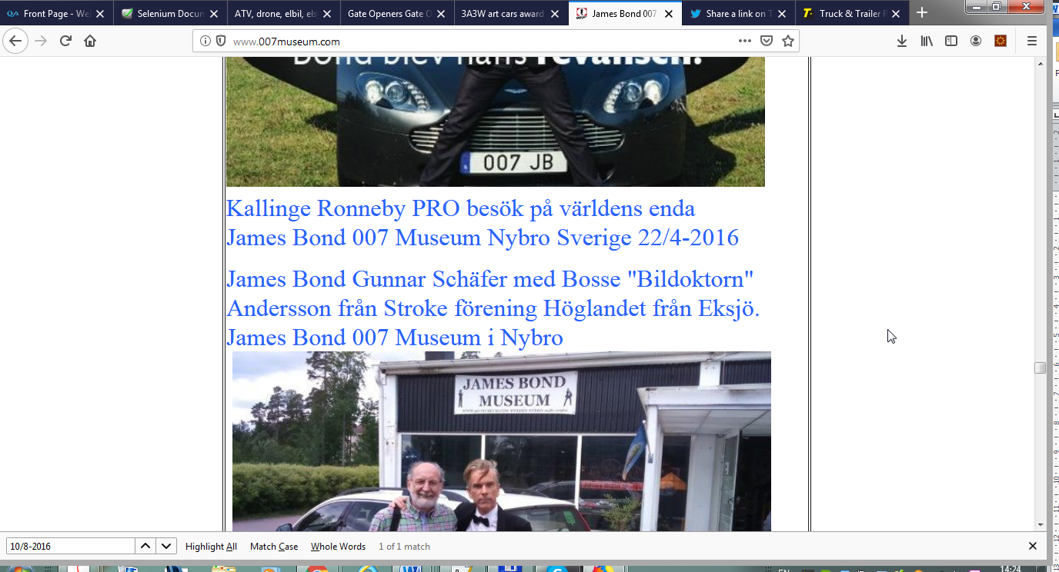

The link is not displayed properly

**Used Device/Browser:**

- Firefox (Version 69.0.1 (64-bit)) on Windows 7

**Steps to reproduce:**

- Open the <http://www.007museum.com/>

- Open find on this page ctrl + f

- paste this: Aqua Terra - James

- Check the link

- It is not displayed correctly

Screenshot:

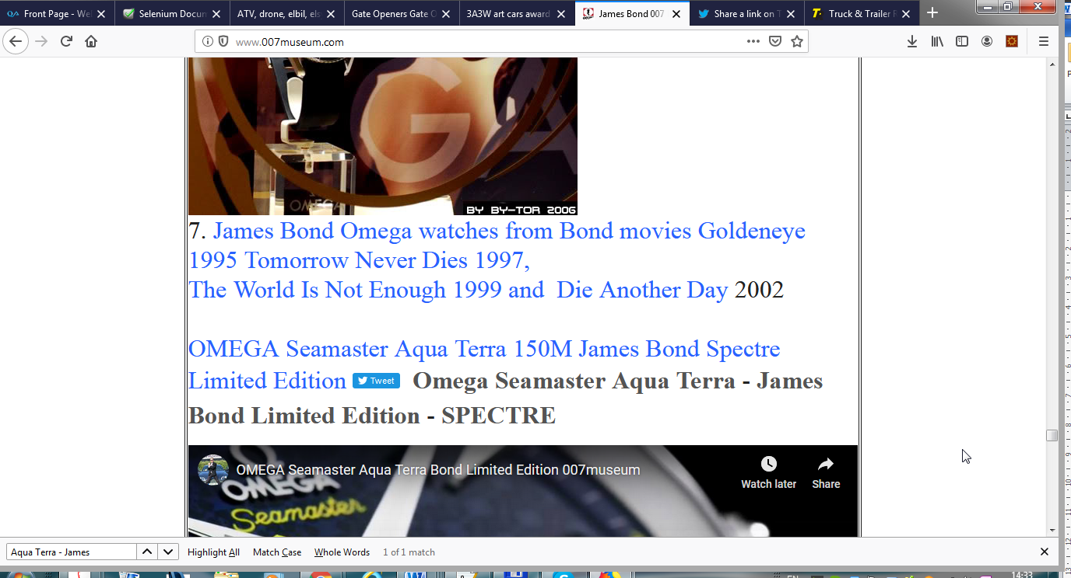

The link is not displayed properly

**Used Device/Browser:**

- Firefox (Version 69.0.1 (64-bit)) on Windows 7

**Steps to reproduce:**

- Open the <http://www.007museum.com/>

- Open find on this page ctrl + f

- paste this: Aqua Terra - James

- Check the link

- It is not displayed correctly

Screenshot:



The link is not displayed properly

**Used Device/Browser:**

- Firefox (Version 69.0.1 (64-bit)) on Windows 7

**Steps to reproduce:**

- Open the <http://www.007museum.com/>

- Open find on this page ctrl + f

- paste this: American ornithologist

- Check the link

- It is not displayed correctly

Screenshot:

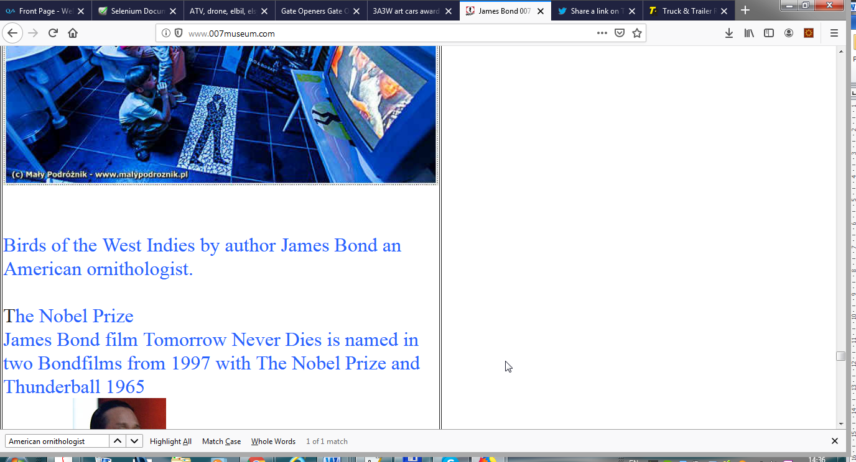

The text missing

**Used Device/Browser:**

- Firefox (Version 69.0.1 (64-bit)) on Windows 7

**Steps to reproduce:**

- Open the <http://www.007museum.com/>

- Open find on this page ctrl + f

- paste this: License förnyas

- Check the text

- Missing double quotes

Screenshot:

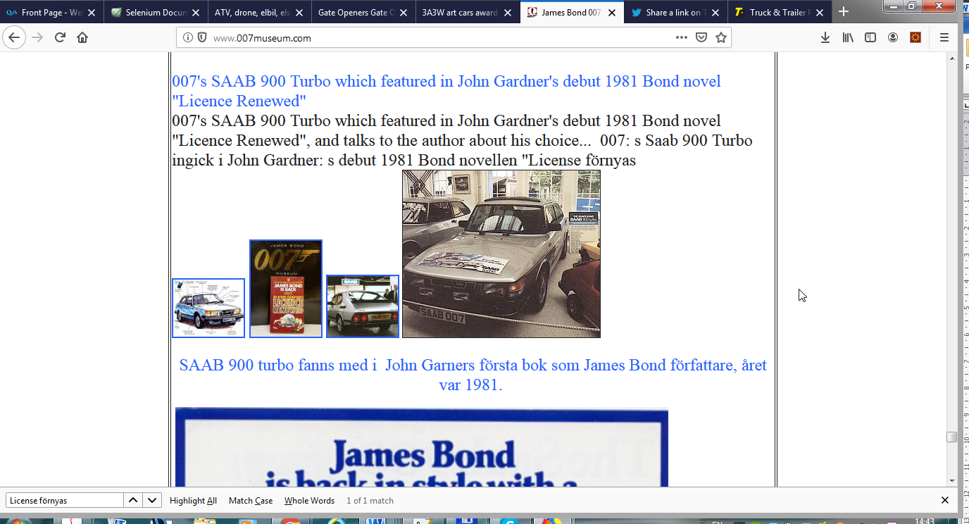

The link is not displayed properly

**Used Device/Browser:**

- Firefox (Version 69.0.1 (64-bit)) on Windows 7

**Steps to reproduce:**

- Open the <http://www.007museum.com/>

- Open find on this page ctrl + f

- paste this: Hines intervju with

- Check the link

- It is not displayed correctly

Screenshot:

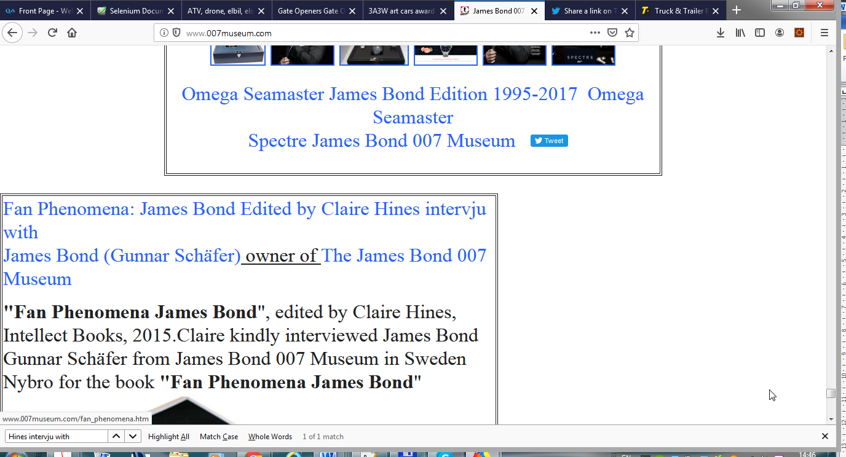

The link is not displayed properly

**Used Device/Browser:**

- Firefox (Version 69.0.1 (64-bit)) on Windows 7

**Steps to reproduce:**

- Open the <http://www.007museum.com/>

- Open find on this page ctrl + f

- paste this: Visitors in James Bond Museum

- Check the link

- It is not displayed correctly

Screenshot:

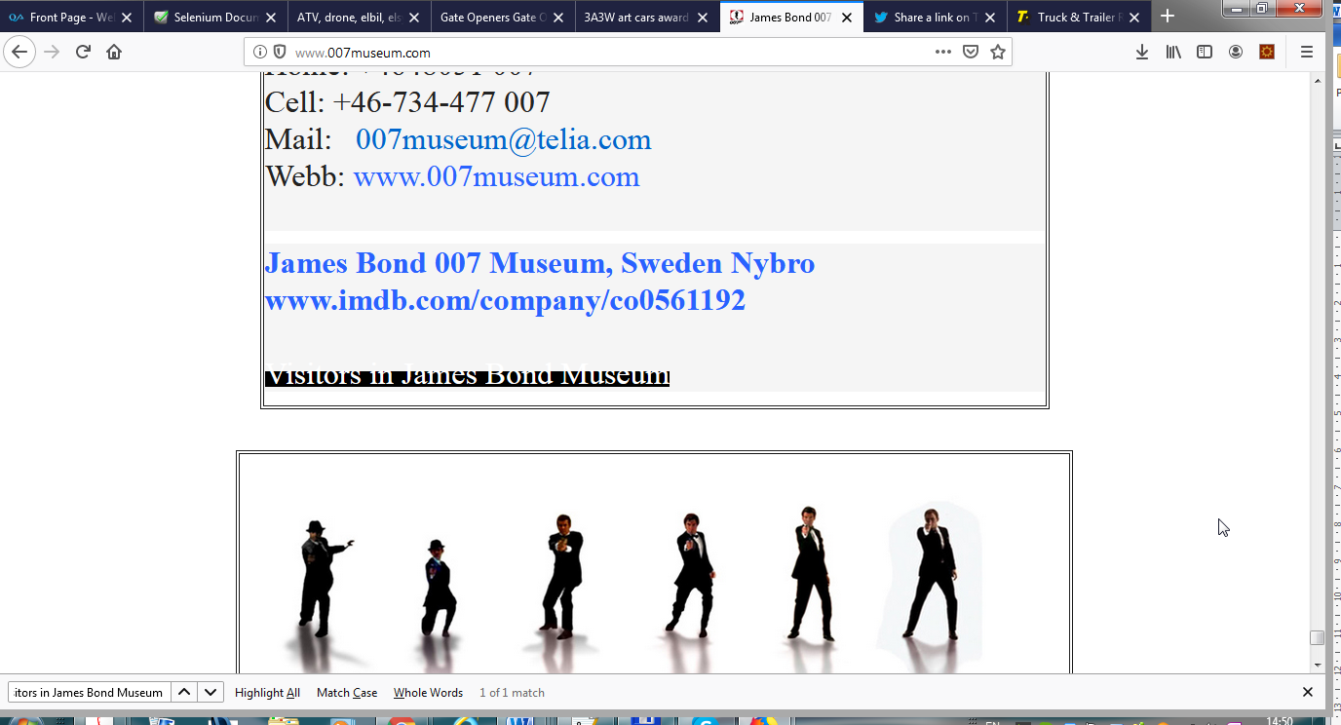

http://www.gatesnfences.com/Automatic_Driveway_gates_1.html

The text is not displayed properly

**Used Device/Browser:**

- Firefox (Version 69.0.1 (64-bit)) on Windows 7

**Steps to reproduce:**

- Open the <http://www.gatesnfences.com/Automatic_Driveway_gates_1.html>

- It is not displayed correctly

Screenshot:

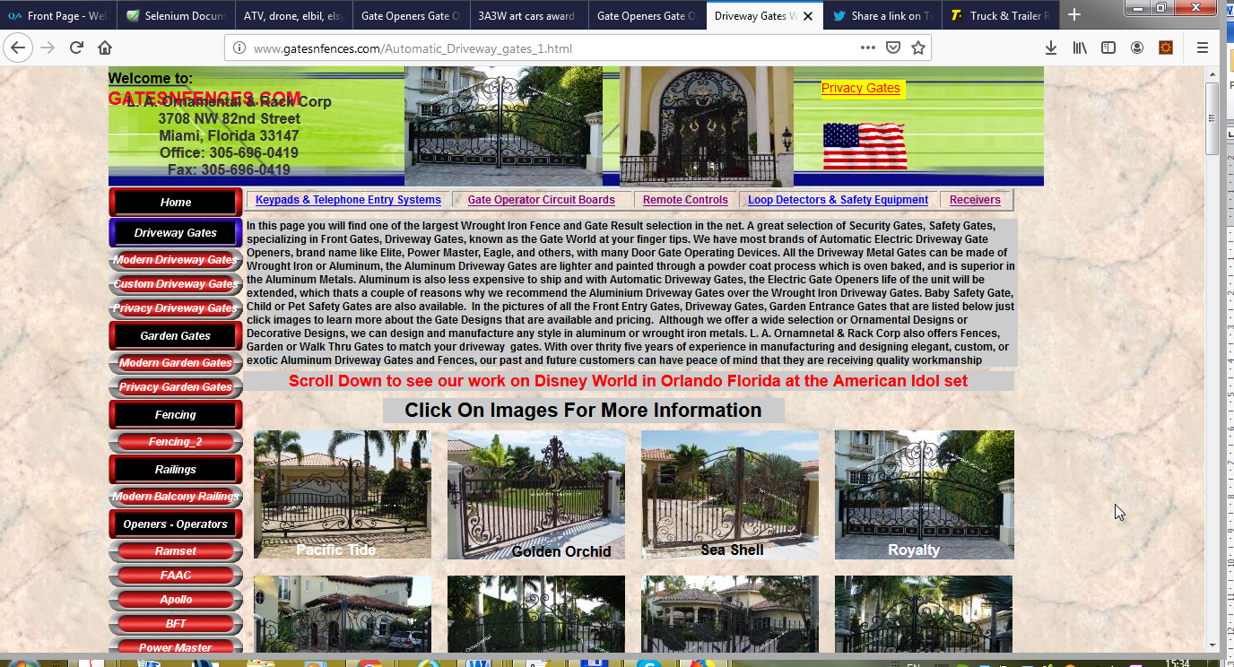

The text is not displayed properly

**Used Device/Browser:**

- Firefox (Version 69.0.1 (64-bit)) on Windows 7

**Steps to reproduce:**

- Open the <http://www.gatesnfences.com/Aluminum_Driveway_Gates_3.html>

- It is not displayed correctly

Screenshot:

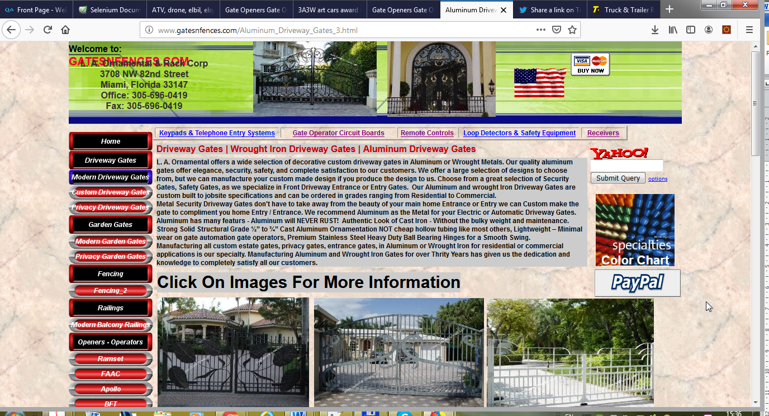

The image text CopyRight info is not displayed

**Used Device/Browser:**

- Firefox (Version 69.0.1 (64-bit)) on Windows 7

**Steps to reproduce:**

- Open the <http://www.gatesnfences.com/Aluminum_Driveway_Gates_3.html>

- Image text CopyRight info is not displayed

- Second row 2st

- Third row 1st

Screenshot:

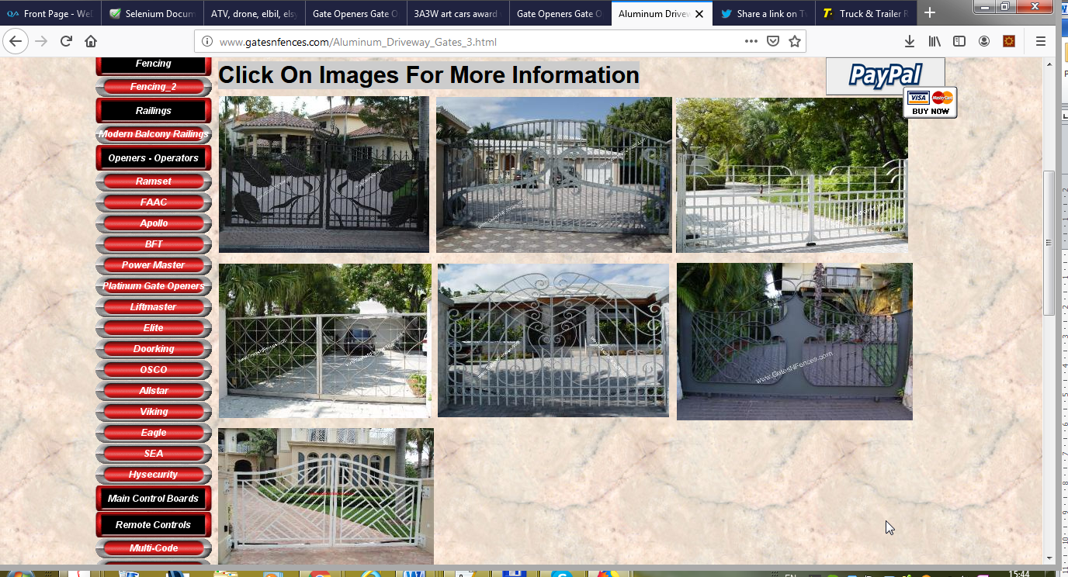

The margin of images not the same

**Used Device/Browser:**

- Firefox (Version 69.0.1 (64-bit)) on Windows 7

**Steps to reproduce:**

- Open the <http://www.gatesnfences.com/Aluminum_Driveway_Gates_3.html>

- The margins of the images are not the same

Screenshot:



The text is not displayed properly

**Used Device/Browser:**

- Firefox (Version 69.0.1 (64-bit)) on Windows 7

**Steps to reproduce:**

- Open the <http://www.gatesnfences.com/Electric_Driveway_gates_2_html.html>

- It is not displayed correctly

Screenshot:



The image text CopyRight info is not displayed

**Used Device/Browser:**

- Firefox (Version 69.0.1 (64-bit)) on Windows 7

**Steps to reproduce:**

- Open the <http://www.gatesnfences.com/Electric_Driveway_gates_2_html.html>

- Image text CopyRight info is not displayed

- Third row 1st

Screenshot:

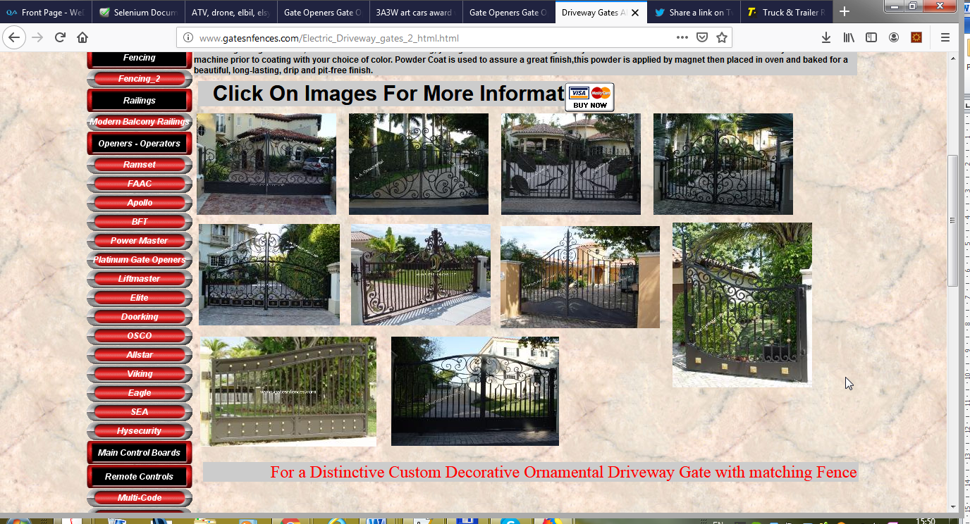

The image link broken

**Used Device/Browser:**

- Firefox (Version 69.0.1 (64-bit)) on Windows 7

**Steps to reproduce:**

- Open the <http://www.gatesnfences.com/Electric_Driveway_gates_2_html.html>

- Image link broken

- Third row 1st

Screenshot:



The text is not displayed properly

**Used Device/Browser:**

- Firefox (Version 69.0.1 (64-bit)) on Windows 7

**Steps to reproduce:**

- Open the <http://www.gatesnfences.com/Privacy_Gates.html>

- Text is not displayed correctly

Screenshot:

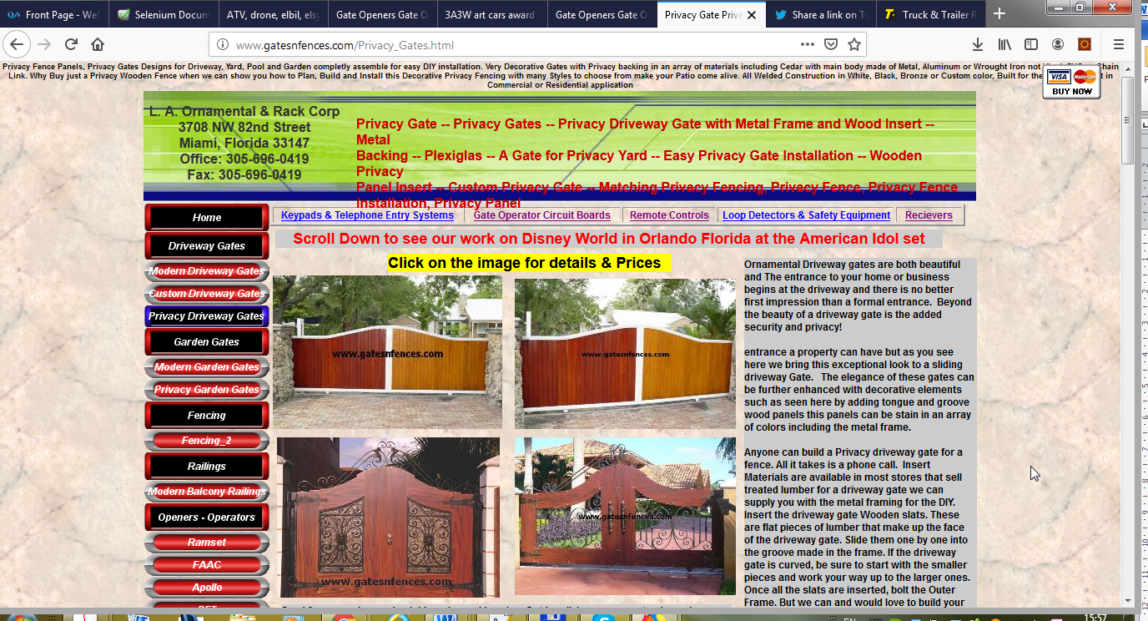

The text is not displayed properly

**Used Device/Browser:**

- Firefox (Version 69.0.1 (64-bit)) on Windows 7

**Steps to reproduce:**

- Open the <http://www.gatesnfences.com/Garden-Gates-Walk-Thru-Gates-Metal-Wrought-Iron-Aluminum-Custom-Designs.html>

- Text is not displayed correctly

- Last char of word

Screenshot:

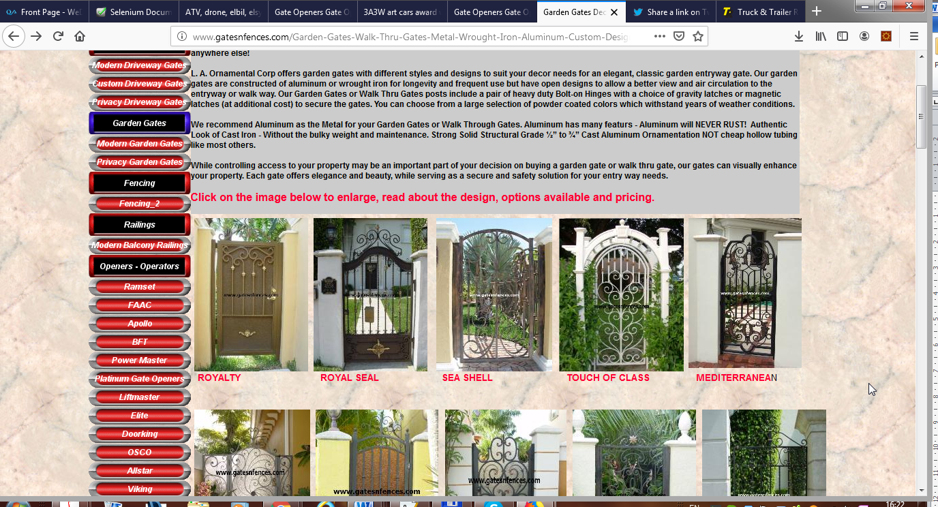

The image link broken

**Used Device/Browser:**

- Firefox (Version 69.0.1 (64-bit)) on Windows 7

**Steps to reproduce:**

- Open the <http://www.gatesnfences.com/Modern-Garden-Gates.html>

- Image link broken

- Third row 1st

Screenshot:

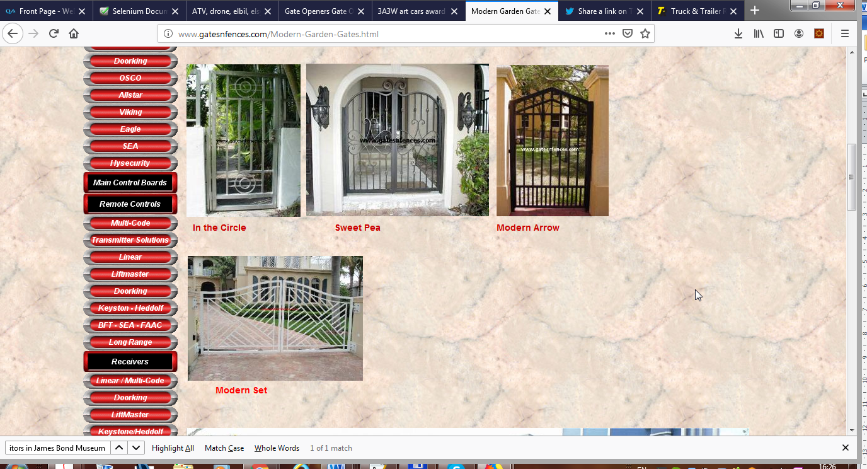

The link without spec name

**Used Device/Browser:**

- Firefox (Version 69.0.1 (64-bit)) on Windows 7

**Steps to reproduce:**

- Open the <http://www.gatesnfences.com/Picket_Fence.html>

- Link without spec name

- When click on link

- Open test page (working in progress)

Screenshot:

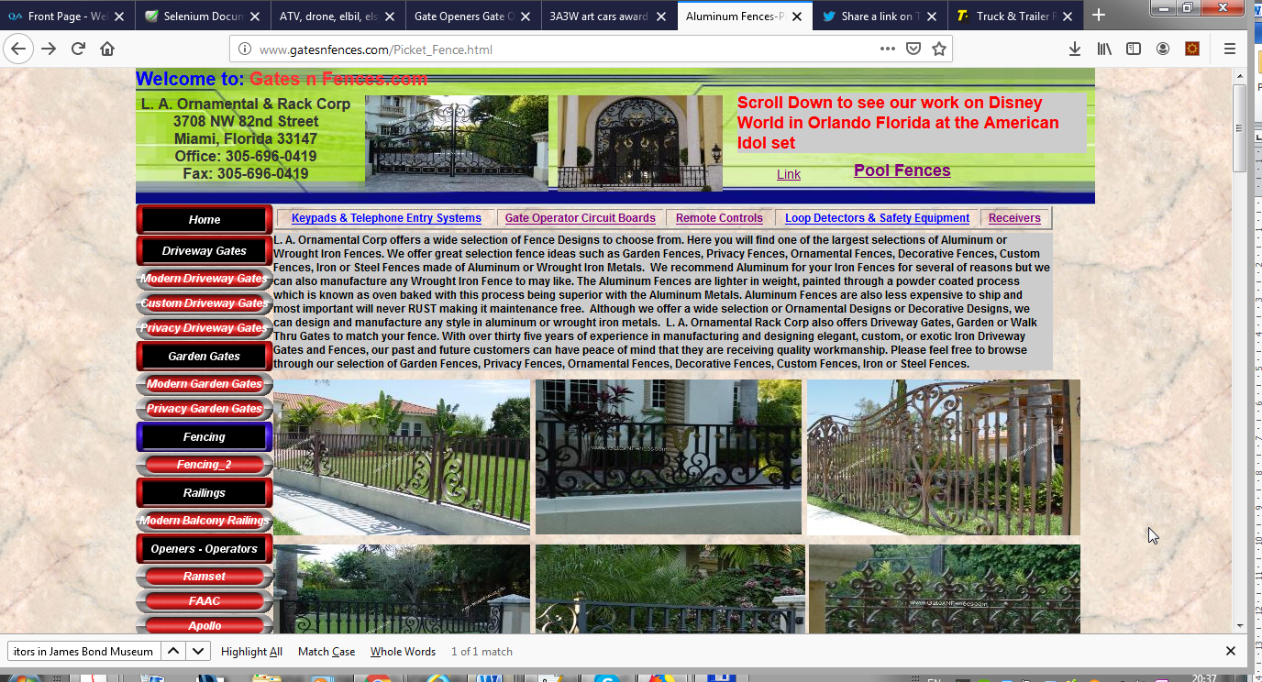

The page is not displayed properly

**Used Device/Browser:**

- Firefox (Version 69.0.1 (64-bit)) on Windows 7

**Steps to reproduce:**

- Open the <http://www.gatesnfences.com/Gate_Opener_RamSet_30_30-30_300_3000_3100_3200_50_100-1000_5000_5100_5200_5500.html>

- Page is not displayed correctly

- Need optimization

- User need to scroll right and left to see all parts of page

Screenshot:

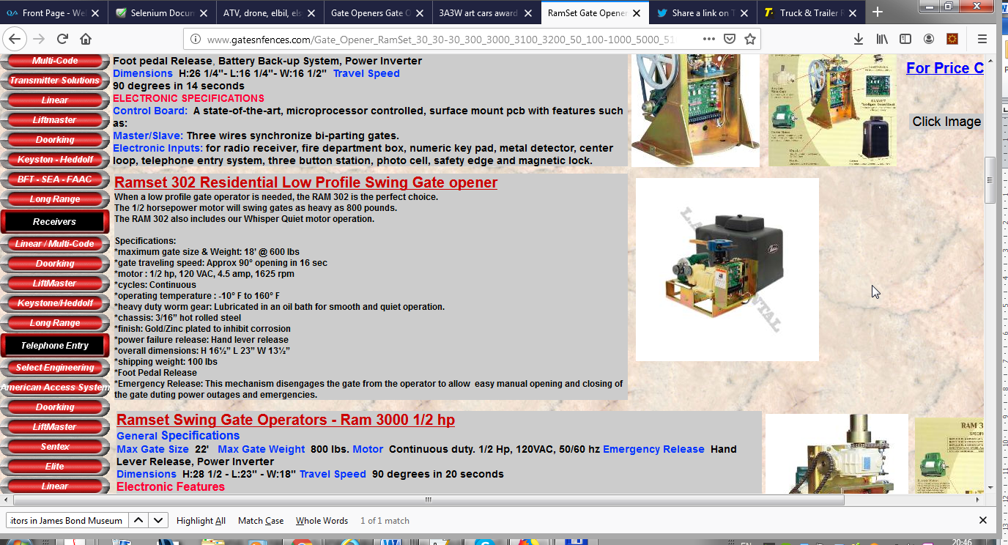

The right side of the checkout page is not displayed properly

**Used Device/Browser:**

- Chrome (Version 55.0.2883.87 (64-bit)) on Windows 10

**Steps to reproduce:**

- Open the XXXXXXXXXXXXXXX page

- Click on the Get button

- The checkout page will be displayed

- Check the right side of the page

- It is not displayed correctly

- Some images and links are missing

Screenshot:

Add here the screenshot of the issue - if the issue is complex record a video instead of a screenshot, upload it and add the link here (you can use recordit.co for screencast)